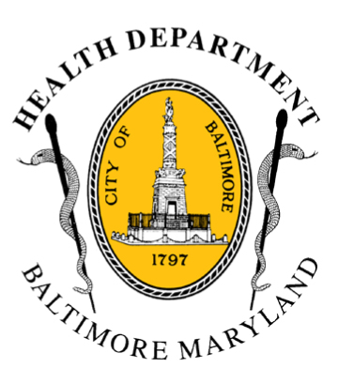
BCHD PRESS RELEASE
Baltimore City Health Department
1001 E. Fayette Street • Baltimore, Maryland 21202
Stephanie Rawlings-Blake, Mayor
Leana Wen, M.D., Commissioner of Health

FOR IMMEDIATE RELEASE
Media Contact: Michael Schwartzberg, PIO
O: (443) 984-2623 C: (443) 462-7939 E: michael.schwartzberg@baltimorecity.gov

Baltimore City Health Commissioner Encourages Citizens To Take Precautions As Season’s First Hot Weather Arrives

BALTIMORE, MD (June 12, 2015) – With forecasted temperatures in the mid-90s, a heat index expected to reach 100 degrees and unhealthy air quality, Baltimore health officials are encouraging residents to take precautions as the first hot weather of the season arrives today.

“Individuals should stay indoors in air-conditioning as much as possible and be sure to stay hydrated with water today,” said Dr. Leana Wen, Baltimore City Health Commissioner, noting the National Weather Service has issued a Heat Advisory for today from 12 noon through 8 p.m. “We are especially concerned about our vulnerable individuals, including children, the elderly, and people with medical conditions such as asthma, heart disease or lung disease.”

Although the weather forecast does not meet the threshold for a Code Red declaration (heat index of 105 degrees or greater), there is a significant risk today of heat-related illness for those without air-conditioning or who are outdoors for an extended period of time.

“Heat is one of the leading weather-related killers in the United States, resulting in hundreds of people dying and thousands becoming ill every year,” said Dr. Wen. “Heat waves are silent killers and a public health threat, particularly for the young, the elderly and those in our city who are the most vulnerable.”

During periods of extreme heat, the Baltimore City Health Department recommends that city residents:

- Drink plenty of water and avoid alcohol and caffeine
- Reduce outside activities and stay inside in air-conditioned locations
- Never leave children or pets alone in closed vehicles, even for short periods of time
- Check on older, sick, or frail neighbors who may need help responding to the heat
- Watch out for signs of heat exhaustion and heat stroke, which include:
- Confusion
- Hot, dry, flushed skin or cool and clammy skin
- Lighheadedness
- Nausea
- Call 911 immediately if any of these symptoms occur

For more information on the hot weather, citizens can check the Health Department website, health.baltimorecity.gov, and the agency’s social media accounts (Twitter - @Bmore_Healthy and Facebook - www.facebook.com/BaltimoreHealth).
###

